AUTOMATION of a BATTLE TANK

Project Report
AC & DC Machines Lab

Group Members:
Abdullah Tahir 2009-MC-106
Ali Raza Aasif 2009-MC-110

Group Members:
Abdullah Tahir 2009-MC-106
Ali Raza Aasif 2009-MC-110

University of Engineering and Technology
FSD-Campus
STEPPER MOTOR

In Theory, a Stepper motor is a marvel in simplicity. It has no brushes, or contacts. Basically it's a synchronous motor with the magnetic field electronically switched to rotate the armature magnet around.

Definition
A stepper motor is basically an electromechanical device which converts electrical pulses into discrete mechanical movements. The shaft or spindle of a stepper motor rotates in discrete step increments when electrical command pulses are applied to it in the proper sequence. The motors rotation has several direct relationships to these applied input pulses. The sequence of the applied pulses is directly related to the direction of motor shafts rotation. The speed of the motor shafts rotation is directly related to the frequency of the input pulses and the length of rotation is directly related to the number of input pulses applied.

Characteristics
• Holding Torque - Steppers have very good low speed and holding torque. Steppers are usually rated in terms of their holding force (oz/in) and can even hold a position (to a lesser degree) without power applied, using magnetic 'detent' torque.
• Open loop positioning - Perhaps the most valuable and interesting feature of a stepper is the ability to position the shaft in fine predictable increments, without need to query the motor as to its position. Steppers can run 'open-loop' without the need for any kind of encoder to determine the shaft position. Closed loop systems- systems that feed back position information, are known as servo systems. Compared to servos, steppers are very easy to control; the position of the shaft is guaranteed as long as the torque of the motor is sufficient for the load, under all its operating conditions.
• Load Independent - The rotation speed of a stepper is independent of load, provided it has sufficient torque to overcome slipping. The higher rpm a stepper motor is driven, the more torque it needs, so all steppers eventually poop out at some rpm and start slipping. Slipping is usually a disaster for steppers, because the position of the shaft becomes unknown. For this reason, software usually keeps the stepping rate within a maximum top rate. In applications where a known RPM is needed under a varying load, steppers can be very handy.

Working:
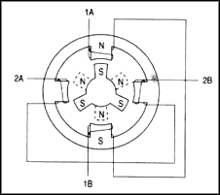
The stepper motor uses the theory of operation for magnets to make the motor shaft turn a precise distance when a pulse of electricity is provided. You learned previously that like poles of a magnet repel and unlike poles attract. Figure 1 shows a typical cross-sectional view of the rotor and stator of a stepper motor. From this diagram you can see that the stator (stationary winding) has four poles, and the rotor has six poles (three complete magnets). The rotor will require 12 pulses of electricity to move the 12 steps to make one complete revolution. Another way to say this is that the rotor will move precisely 30° for each pulse of electricity that the motor receives. The number of degrees the rotor will turn when a pulse of electricity is delivered to the motor can be calculated by dividing the number of degrees in one revolution of the shaft (360°) by the number of poles (north and south) in the rotor. In this stepper motor 360° is divided by 12 to get 30°.
Diagram shows the position of the six-pole rotor and four-pole stator of a typical stepper motor
When no power is applied to the motor, the residual magnetism in the rotor magnets will cause the rotor to detent or align one set of its magnetic poles with the magnetic poles of one of the stator magnets. This means that the rotor will have 12 possible detent positions. When the rotor is in a detent position, it will have enough magnetic force to keep the shaft from moving to the next position. This is what makes the rotor feel like it is clicking from one position to the next as you rotate the rotor by hand with no power applied.
When power is applied, it is directed to only one of the stator pairs of windings, which will cause that winding pair to become a magnet. One of the coils for the pair will become the north pole, and the other will become the south pole. When this occurs, the stator coil that is the north pole will attract the closest rotor tooth that has the opposite polarity, and the stator coil that is the south pole will attract the closest rotor tooth that has the opposite polarity. When current is flowing through these poles, the rotor will now have a much stronger attraction to the stator winding, and the increased torque is called
holding torque.
By changing the current flow to the next stator winding, the magnetic field will be changed 90°. The rotor will only move 30° before its magnetic fields will again align with the change in the stator field. The magnetic field in the stator is continually changed as the rotor moves through the 12 steps to move a total of 360°.
Shortcut for finding the proper wiring sequence
For 5 wires – 1 is common to be plugged at positive supply and rest four to the pulses. For 6 wires – 2 are common to be plugged at positive supply and rest four to the pulses.
Connect the center tap(s) to the power source (or current-Limiting resistor.) Connect the remaining 4 wires in any pattern. If it doesn't work, you only need try these 2 swaps...
1 2 3 4 - (arbitrary first wiring order)
1 2 4 3 - switch end pair
1 4 2 3 - switch middle pair
You're finished when the motor turns smoothly in either direction. If the motor turns in the opposite direction from desired, reverse the wires so that ABCD would become DCBA.

PARALLEL PORT

What is a port?
A port contains a set of signal lines that the CPU sends or receives data with other components. We use ports to communicate via modem, printer, keyboard, mouse etc. In signaling, open signals are "1" and close signals are "0" so it is like binary system. A parallel port sends 8 bits and receives 5 bits at a time. The serial port RS-232 sends only 1 bit at a time but it is multidirectional so it can send 1 bit and receive 1 bit at a time...

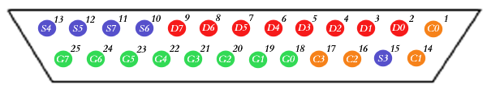
Pins Table

Signal | BIT | PIN | Direction
-Strobe | ¬C0 | 1 | Output
+Data Bit 0 | D0 | 2 | Output
+Data Bit 1 | D1 | 3 | Output
+Data Bit 2 | D2 | 4 | Output
+Data Bit 3 | D3 | 5 | Output
+Data Bit 4 | D4 | 6 | Output
+Data Bit 5 | D5 | 7 | Output
+Data Bit 6 | D6 | 8 | Output
+Data Bit 7 | D7 | 9 | Output
-Acknowledge | S6 | 10 | Input
+Busy | ¬S7 | 11 | Input
+Paper End | S5 | 12 | Input
+Select In | S4 | 13 | Input
-Auto Feed | ¬C1 | 14 | Output
-Error | S3 | 15 | Input
-Initialize | C2 | 16 | Output
-Select | ¬C3 | 17 | Output
Ground | - | 18-25 | Ground

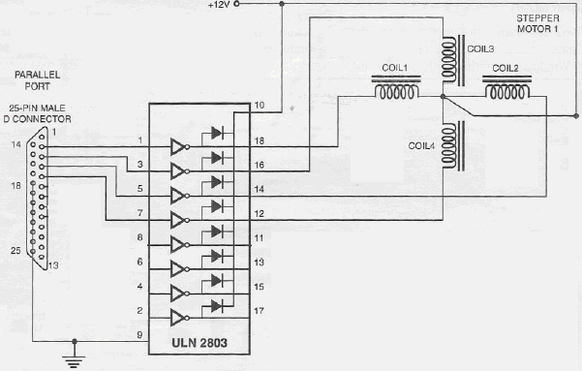
Circuit for Controlling Stepper Motor

DC Motors
DC Motors are those which operate at DC current. DC current is provided to the rotor and then rotor rotates due to force acting on the conductors.
LEDs
LEDs are light emitting diodes. As it is obvious from its name that these are simple diodes which emit light. When positive terminal of LED is attached with positive terminal of battery and negative terminal with corresponding terminal then it emits light. But when opposite terminals are attached then no current flows causing it not to glow.

How is it Automatic?
No need of driver sitting in the tank. Drive and its assistant and other cops have thrill of life. They don’t know either they will be alive or dead at the next moment.
So this tank can help them to operate it just sitting in the control room. He would really enjoy his fight on computer.
Suppose he knows the exact location of enemies by satellite system. Then what he has to do is to give exact angle to the canon. The canon will rotate in desired direction and fire button will fire the bomb.
And if he doesn’t know the exact location of enemies then he can rotate the canon by left, right buttons.

Project Features
- Canon can rotate at any angle
- Four wheel drive
- Front lights
- Simple mechanism for left, right turn
- Colorful lights to increase its beauty
- A radar
- Circuit is simple and clearly seen
